Phase I and Phase II Results – Idaho (ID)

A. Introduction

B. Plot of Lagged Predictors vs. HPI (simple returns)

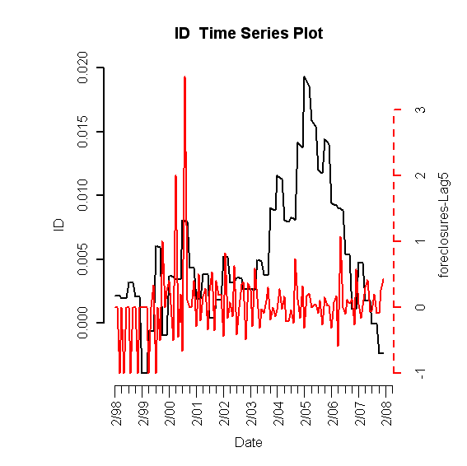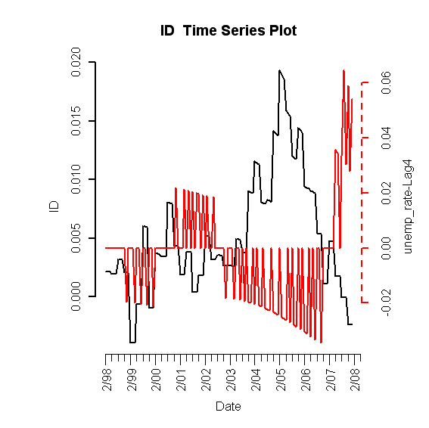
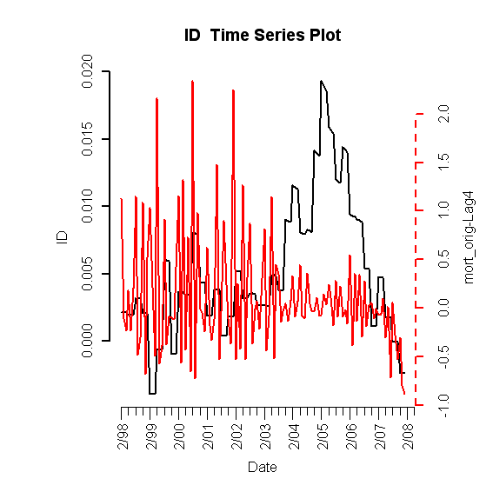
Figure I.1: Lagged predictors vs. Idaho HPI

B. Final Multivariate Model

Table 1: Fitted drift model
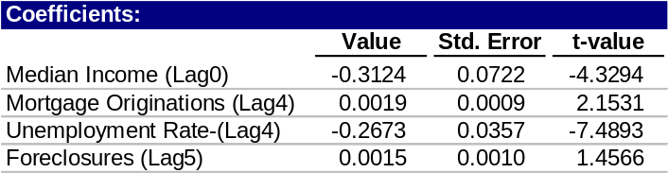

1. Phase I: Drift Model

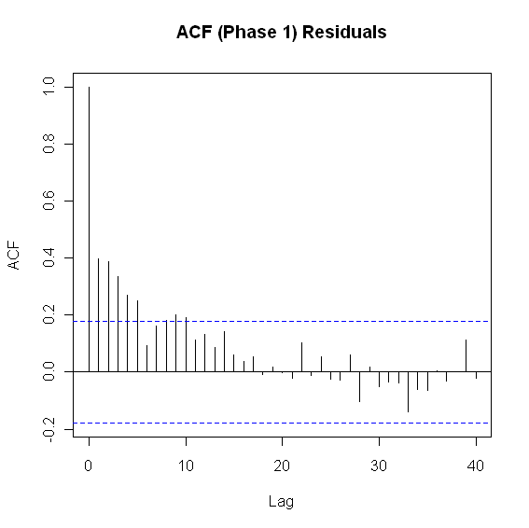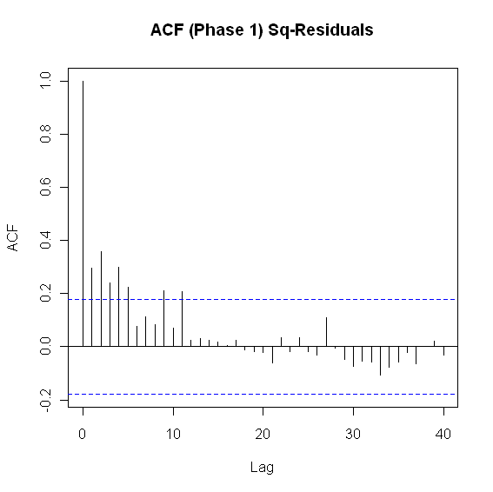
Figure I.2: ACF of residuals (left) and squared residuals (right) of fitted linear model

2. Phase II: Volatility Model

Table 2: Idaho fitted volatility model
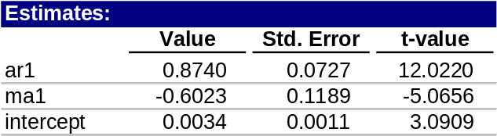

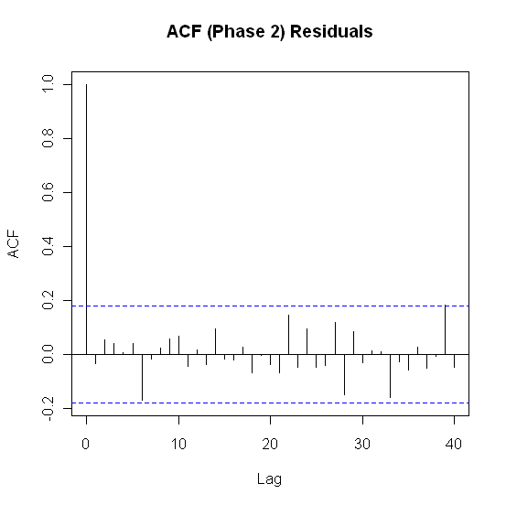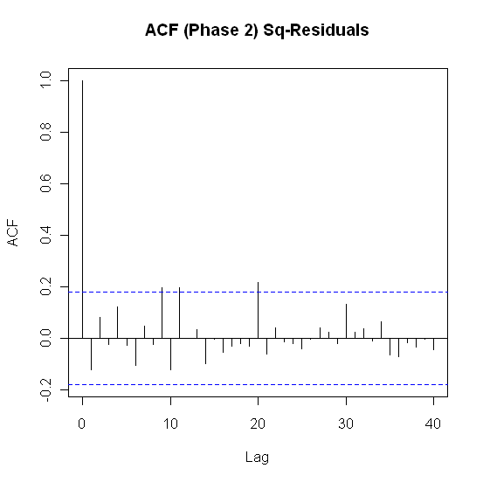
Figure I.3: ACF of residuals (left) and squared residuals (right) of the Phase II model for Idaho

3. Model Checking Diagnostics

Table 3: Statistical test results for complete model
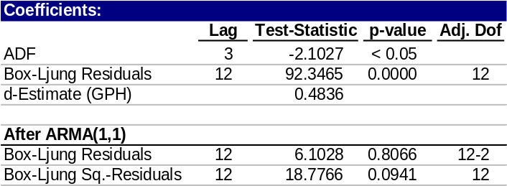

C. Fitted vs. Actual Plots

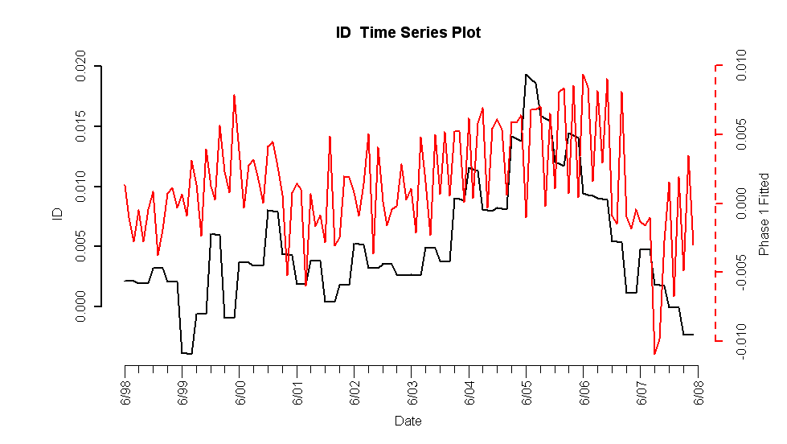
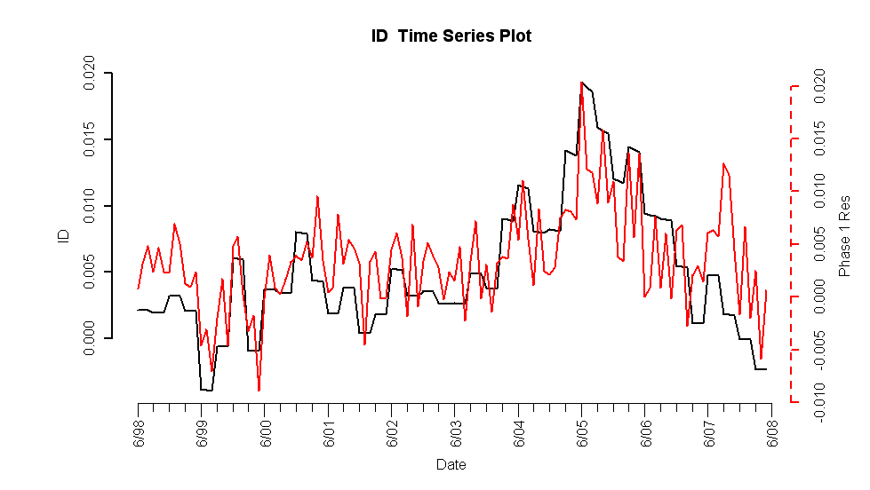
Figure I.4: Fitted Phase I vs. Idaho HPI (top) and residuals (bottom)

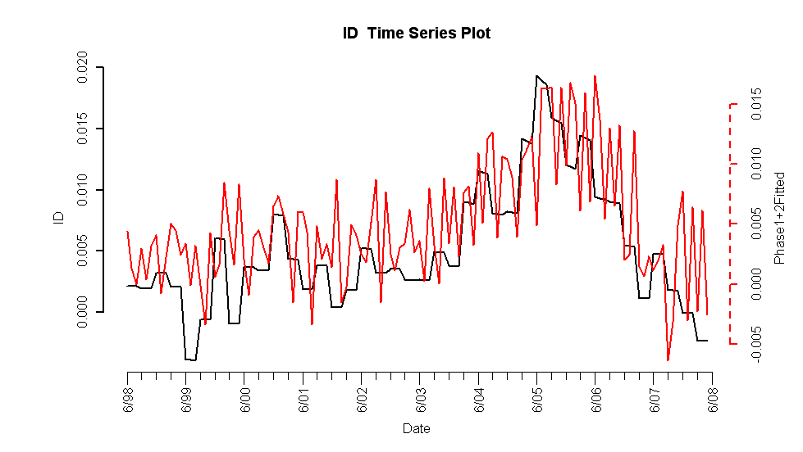
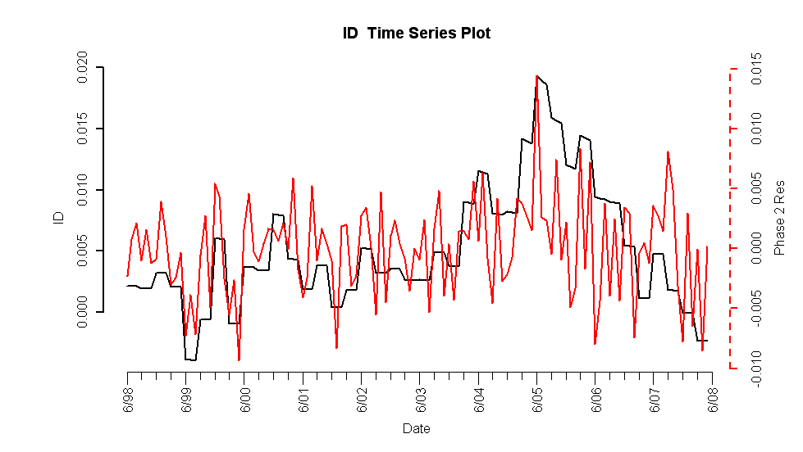
Figure I.5: Complete fitted model vs. Idaho HPI (top) and residuals (bottom)

D. Forecasts

Figure I.6: 5-year forecasted simple returns (top) and forecasted HPI (bottom)

E. Interpretation of Forecasts

